Cabri Branch Library – November Events 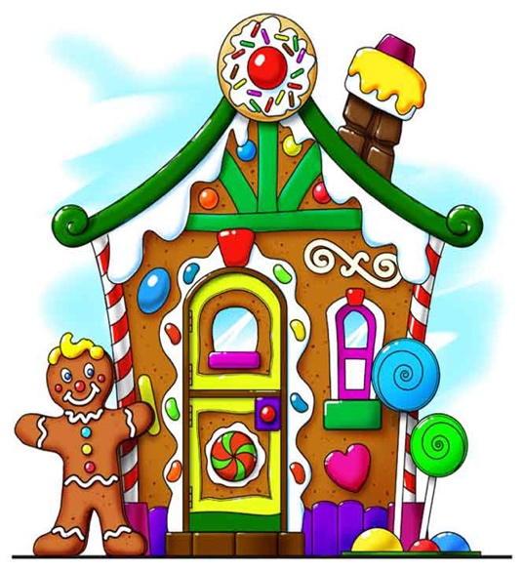
Nov. 27th - Movie – 2:00 pm – Come join us at the library (town council chambers) for the Christmas movie “Santa Paws.” We will provide snack and a juice box. All ages welcome. (There is no school this day)
Gingerbread House Contest - Nov. 15, 22, 29 and Dec. 6:
We will supply the basics and you bring what you need to make your house your own (like colored icing, candies, decorations, etc.). Then on Dec. 11, 13 and 18, will be a time to ask friends and family to come vote for “People’s Choice Award” prizes will be awarded in each age category. Winner announced Dec. 20th. You MUST preregister by Nov. 8th so we can get supplies. We will assign you ONE of those days to come build because we just have room for a few at a time. Come as a team or by yourself. Under 8 MUST have an adult or teen to help. We CANNOT ensure participation without preregistration due to us guarenteeing enough pre-purchased supplies that are the same for everyone.
Christmas Holiday Reading Challenge – Stop in the library between Dec. 11th and 18th for the challenge. Prizes for most read books in each age level. (All kids welcome!)
Watch for more exciting events coming in January like beginner crocheting, more movie days and much, much more!! Contact us Mon. 12:30-5:00 pm or Wed. from 9:00-5:00 pmat 306-587-2911 or text Alanna at 306-741-6943 for more info or to register.

