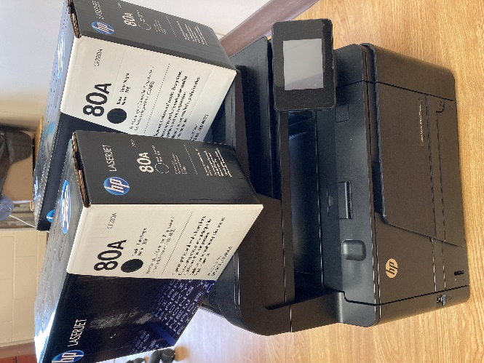

FOR SALE BY TENDER
The Town of Cabri is offering the following for tender:
HP LASER JET PRO 400 MFP m425dn black and white printer plus two ink cartridges.
Tender open to public until Thursday, July 7 at 4:00pm.
Tenders may be sent to:
Town of Cabri
Box 200
Cabri, SK S0N 0J0

OR

townofcabri@sasktel.net

OR

306-587-2392 (fax)

Highest or any bid not necessarily accepted. Successful bidder will be notified by July 12, 2022.

