NOTICE OF POWER OUTAGE- CENTRE ST. & 1ST ST N.
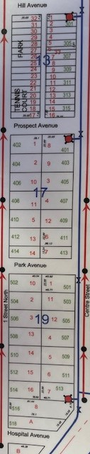
K-LINE CONSTRUCTION, A SUB-CONTRACTOR FOR SASKPOWER, WILL BE REPLACING A POWER POLE IN THE ALLEY AT 309 CENTRE STREET ON THURSDAY, MARCH 21 DURING THE HOURS OF 9:00AM AND 2:00PM.
THIS WORK WILL AFFECT THE FOLLOWING AREAS (ALSO SEE MAP):
CENTRE STREET- HILL AVENUE (300 BLOCK) TO HOSPITAL AVENUE (500 BLOCK) ODD HOUSE NUMBERS ONLY
1ST STREET NORTH - HILL AVENUE (300 BLOCK) TO HOSPITAL AVENUE (500 BLOCK) EVEN HOUSE NUMBERS ONLY

IF YOU HAVE ANY QUESTIONS OR CONCERNS YOU MAY CONTACT SASKPOWER AT saskpower.com OR 1-888-757-6937.

