TOWN OF CABRI

EMERGENCY PLAN

Council adopted: May 12, 2014
Updated May 30, 2022

TABLE OF CONTENTS

SECTION 1 EMO CHECKLIST 10.2 Evacuation Centre
10.3 Accommodation and Meals
2.11 Resources
SECTION 2 EMERGENCY PLAN
SECTION 3 BYLAW
2.1 Purpose
  - Exception SECTION 4 HOUSEHOLD PLAN

  - Authority SECTION 5 EVACUATION PLAN

  - Definitions 5.1 Evacuation Map

  - Implementation SECTION 6 COMMUNICATION PLAN

  - Organization and Emergency Control Group 6.1 Priority Contact List
  - Communication Fan-Out Chart
  - On-Site Operations Groups

  - Operations
  - Policy
7.2 General Procedures SECTION 7 STREET CAPTAINS

2.8 Communications Procedures SECTION 8 EMERGENCY SCENARIOS
8.1 Systems
8.2 Information SCHEDULE 1 DEPUTY MAYOR ROTATION
8.3 Records

2.9 Evacuation and Re-entry
9.1 Evacuation Procedures
9.1.1 General
9.1.2 Warning
9.1.3 Transportation
9.1.4 Security
9.2 Re-Entry Procedures

2.10 Reception
10.1 Reception Procedures

SECTION 1

TOWN OF CABRI EMERGENCY MEASURES ORGANIZATION

APPOINT EMO COORDINATOR & COMMITTEE

DEVELOP MANAGEMENT & CONTROL STRUCTURE

DEVELOP A SYSTEM TO INITIATE AN EMERGENCY CONTROL CENTRE

IDENTIFY POTENTIAL EMERGENCIES

IDENTIFY RESOURCES THAT ARE AVAILABLE WITHIN THE TOWN OF CABRI & RESOURCES THAT MAY NEED TO BE BROUGHT INTO THE
TOWN OF CABRI IN CASE OF AN EMERGENCY

IDENTIFY AN EVACUATION CENTRE

DEVELOP A COMMUNICATION PLAN (ONE FOR EMERGENCY
STAFF AND A SEPARATE ONE FOR RESIDENTS & BUSINESSES)

DRAFT AN EMERGENCY PLAN WHICH INCLUDES A DESCRIPTION OF OFFICIALS & THEIR ROLES AND RESPONSIBILITIES

SECTION 2

EMERGENCY PLAN

Introduction

The contents of this Emergency Plan provide guidance for the Town of Cabri to respond to an emergency.

This Document will not prevent nor reduce the possibility of an emergency occurring. It will aid in providing a prompt and co-ordinated response, thereby reducing human suffering and loss or damage to property.

The public must be informed about the Emergency Plan and educated as to certain elements (e.g. warning and evacuation procedures).

This Emergency Plan authorizes the taking of extraordinary action by Police, fire and/or other emergency response personnel for the safety and well being of the community where time is of critical importance.

_______________________
Mayor David Gossard
Town of Cabri

Town of Cabri

Emergency Plan

1. PURPOSE

The purpose of this Emergency Plan is to provide for a prompt and co-ordinated response to emergencies affecting the Town of Cabri.

  - EXCEPTION

This Emergency Plan does not apply to those day-to-day situations which can be handled by the responsible municipal service(s) in its (their) own.

2. AUTHORITY

This Emergency Plan is authorized in accordance with:

Bylaw No. 5-2008 of the Town of Cabri dated the 19th day of March, 2008.

3. DEFINITIONS

3.1 Emergency A present or foreseeable event which requires prompt
co-ordination of action or the special regulation or control
of persons or property to protect the safety and welfare of people and/or to limit damage to property.

3.2 EMO Co-ordinator That person appointed by resolution as the Emergency
Co-ordinator for the Town of Cabri.

3.3 Municipal Service Means Fire, Police, Ambulance/Hospital, Public Works
and other agencies operating within the jurisdiction of
the Town of Cabri.

3.4 Resource Means personnel, equipment and operational supplies
available for use during a period of emergency.

4. IMPLEMENTATION

  - This Emergency Plan will be implemented in part or in whole when an emergency has occurred or threatens to occur. Implementation will be authorized by:

      - the EMO, Kim Gehl
      - the Mayor, David Gossard
      - in the absence of the Mayor, the Deputy Mayor (see Schedule 1)
      - the Fire Chief, Lindsay Higginbotham
      - in the absence of the Mayor, Deputy Mayor and Fire Chief, the Town Administrator, Janelle Desautels or alternate Assistant Administrator, Kristi Jamieson
      - Or, by other Municipal Service authorized to act in accordance with this Emergency Plan.

  - The taking of extraordinary action by Municipal Service constitutes implementation of this Emergency Plan.

5. ORGANIZATION AND EMERGENCY CONTROL GROUPS
DESIGNATION AND DUTY | NAME
EMO Coordinator  - Direct & control the emergency operations at all times  - Inform Province of emergency and request assistance as required  - Keep CAO informed of developments  - Initiate evacuation plan, if necessary  - Ensure all directions from the Mayor and Council are carried out.  - Liaise with emergency personnel  - Ensure annual updating of the emergency plan.  - Ensure that the public is informed bi-annually as to warning and evacuation procedures. | Kim Gehl  Alternate:  Mike Wicks
Mayor  - Declare an emergency in accordance with proper procedure (see Section 8)  - Request Council meeting, if required (approval of financial expenditures, etc.) | David Gossard
Deputy Mayor/Council Members  - Assume responsibility in the absence of the Mayor  -Participate with the Mayor and EMO in the decision-making process | Kim Gehl
 | Norma Pederson
 | Wendy Johnson
 | Kim Lacelle
 | Jim Wallis
 | Dani Sorenson
Fire Chief  - Assist EMO as necessary  - Coordinate fire response | Lindsay Higginbotham
Chief Administrative Officer  - If EMO authorizes, contact province (SaskAlert) to inform of emergency and/or initiate evacuation plan  - Keep Mayor, council, town foreman, fire chief and communication coordinator informed and up-to-date  - Advise Mayor and Council on legislation and procedures  - Arrange Council meeting, if required and record minutes  - Take/give instructions from the coordinators of different groups  - Assist with the development of mutual aid agreements with neighboring municipalities  - Maintain financial and other records pertaining to the event | Janelle Desautels  Alternate: Kristi Jamieson
Town Foreman/Utility Agency  - Water  - Back-up emergency power | Sid Sirota
Communication Coordinator  - Initiate Communication Plan (See Section 6)  - Remain in close contact with CAO and/or EMO to keep residents up-to-date on developments of emergency  - Liaise with Street Captains and other Coordinators as necessary | Brenda Heron
Evacuation Coordinator  - Advise Facility Coordinator of need to open Evacuation Centre if necessary  - Advise Transportation Coordinator of possibility of need to transport people  Liaise with Communications Coordinator informing residents of necessary evacuation | *Assigned on Site by CAO/Council/FD
Transportation Coordinator  - Coordinate transportation of residents and persons within the Town to the designated Evacuation Centre, as required | *Assigned on Site by CAO/Council/FD
Supplies Coordinator  - Acquire necessary supplies (meals/blankets/cots ect.) as required | *Assigned on Site by CAO/Council/FD
Facility Coordinator  - Coordinate opening and readying of Evacuation Centre  - Coordinate registration of people being received at Evacuation Centre  - Organize meals and other needs for persons at Evacuation Centre along with the Supplies Coordinator | *Assigned on Site by CAO/Council/FD
Phoning Coordinator  - Phone as required | Assigned on site by EMO or CAO
Health  - Designated individual to coordinate health personnel for emergency incident (public health, mental health, social services etc.) | Tracy Stock, PHCH manager
RCMP  - Coordinate any policing requirements for the emergency incident  - Assist as necessary with Evacuation Plan (see Section 5) | RCMP Detachment
Fire  - Coordinate fire response as necessary  - Assist in evacuation of residents if necessary  - Assist Coordinators as necessary | Lindsay Higginbotham

6. ON-SITE OPERATION GROUPS

DESIGNATION & DUTY | NAME
Site Commander  - Commands emergency on site and communicates with Mayor and CAO providing updates, informing of needs, etc. | EMO, Kim Gehl
Police  - On-site commander when circumstances dictate  - Security at the emergency site  - Temporary morgue if required  - Assist in the evacuation of people | RCMP Detachment
Fire  - On-site commander when circumstances dictate  - Assistance in the evacuation of people.  - Initiate mutual aid if required | Fire Chief Lindsay Higginbotham
Ambulance  - Medical supplies & transportation of patients as required | 9-1-1

- OPERATIONS

7.1 Policy
The Town of Cabri must depend entirely upon its own resources during the initial impact of an emergency.

Provincial and/or Federal assistance will be obtained through established channels only after local resources have been fully committed or when it is clear that local resources will be inadequate.

The Emergency Operations Centre shall be the Cabri Town Office located at 202 Centre Street, Cabri. The alternate Emergency Operations Centre shall be the Abbey Village Office located at 143 Wayne Street, Abbey.

  - General Procedures
Initially Municipal Services will respond to an event. If this event is beyond their capability to handle, the EMO will initiate other services.

The EMO will initiate the plan if required and will contact the Mayor and CAO.

- COMMUNICATIONS PROCEDURES

Whenever the potential for an emergency situation arises, all members of the Organization and Emergency Control Groups should be given a `Heads-Up` notification. This means they are made aware that the Emergency Plan may be implemented, and that they may be contacted by the Communication or other Coordinator.

Once the need for the Emergency Plan has been determined, the Communication Plan will be initiated by the Communication Coordinator, and the Emergency Plan will be activated.

The emergency alerting calls will be made to individuals/agencies listed in the telephone fanout chart below. The caller will first identify themselves and then give the information as provided by the member of the Organization and Emergency Control Group who activated the Emergency Operations Plan. Each caller is responsible for calling their designated contacts following the chart. If the caller is unable to reach one or more of their designated contacts, they must call the contact(s) on the next level of the chart.

A list with telephone numbers will be provided to individuals as a separate and confidential document.

In the event staff cannot be notified by telephone, all members of the Organization and Emergency Control Group are to proceed to the Operations Centre immediately.

Emergency Measures Operator
Alternate Emergency Measures Operator or Phoning Coordinator
Chief Administrative Officer
Provincial Emergency Services Officer

Mayor
Town Foreman
Council Members
Police
Fire
Communication Coordinator-Street Captains

Health/EMS

  - Systems
- Initiate communication plan (see Section 6) including priority contact list and street captains
- Placing bulletin’s in strategic places
- Megaphone
- Radio
- RCMP assistance

8.2 Information
Information released must be precise as to the nature of the emergency, the dangers involved and the actions to be taken.
  - Public Information
The CAO and/or Communication Coordinator will advise the radio station that an emergency exists and will confirm arrangements for the dissemination of information to the citizens and general public.
b) Media Information
The CAO or the designated officer will authorize all information to be released to the news media.

8.3 Records
All communications, correspondence and activities will be recorded and retained for future reference by all persons involved. CAO responsible to collect all information and retain in Town office.

9. EVACUATION AND RE-ENTRY

9.1 Evacuation Procedures
9.1.1 General
In the event that it is necessary to evacuate people; Warning (9.1.2); Transportation (9.1.3) and Security (9.1.4) procedures must be observed.

9.1.2 Warning
The Communication Coordinator will ensure that:
  - Precise information is disseminated to the general public as to the danger involved and actions to be taken.
  - Hospitals, schools, personal care homes, group residences and daycares in the affected area are notified (see priority contact list).
  - Reception communities are notified (Pennant, Hazlet, Abbey).

9.1.3 Transportation
It is anticipated that the majority of people will provide for their own transportation (where applicable).

The Transportation Coordinator will make arrangements to evacuate persons without transportation.

9.1.4 Security

During the emergency period requiring evacuation the Police will be responsible to secure the area.

9.2 Re-Entry Procedures
Re-entry will be initiated as quickly as possible but not before local and provincial authorities are satisfied all appropriate preparations have been made, e.g. The restoration of utilities and essential services to homes and commercial establishments.

- RECEPTION

10.1 Reception Procedures
The Facility Coordinator will register evacuees by name, telephone number and time entered evacuation facility. Coordinator shall enlist help to register evacuees as necessary.

10.2 Evacuation Centre
The SWT Arena shall be the Evacuation Centre for the Town of Cabri.

Events in the neighboring communities may necessitate the reception of evacuees by the Municipality.

10.3 Accommodation and Meals
The Facility Coordinator will notify the Supplies Coordinator to initiate their plan accordingly.

Sources of accommodation and meals:
Rink (option 1) | Wade Petersen
Community Hall (option 2) | Town of Cabri
Cabri School (option 3) | Debbie Thomas
Sunrise Inn Motel | May Santos
Lin’s Restaurant | Priscilla
House of Heart | Paulette Gehl
Pioneer Co-op | Bev Williams
- RESOURCES

Alternative Heat Source | Hospital
Ambulance Services | 9-1-1
Animal & Livestock Services
Arena
Broadcasting Services  Website | Radio - Eagle 94.1
Broadcasting Services  Website | Radio – Magic 97.1  Radio – CKSW 570
Building Material Supplies | Co-op
Catering Services | House of Heart
Catering Services | Co-op
Catering Services | Lin’s
Clergy Assistance
Clergy Assistance | St.Josephs Catholic Church- Cindy Nelson
Construction Equip. Suppliers  - Trucks, water tankers, track hoes, loaders, etc. | Doug Kennedy
 | Kelly Pawluk
 | Rob Heron
 | Bob Kirkpatrick
 | Brad Levorson
Evacuation Centre | Rink
Fire Services | Town Office
Fuel Distributors | Co-op
Funeral Homes | Parkside Memorial
Funeral Homes | Swift Current Funeral Home
Funeral Homes | Warren’s Funeral Home
Generator | Robertson Rentals
Welder Trucks | Jay Shaw
Welder Trucks | GW Green
Welder Trucks | Jeff Lindstrom
Welder Trucks | Scott Andreas
 | Tanner Levorson
Hospital | Prairie Health Centre
Local Stores | Co-op
Media Services | See Broadcasting services
Medical Clinic | Cabri Medical Clinic
Police
Public Works Shop | Town of Cabri
Sanitation Tankers | Limitless Rentals
Service Clubs | Lions
Special Care Facilities | Prairie Health Centre
Special Care Facilities | Senior Housing- Cindy Nelson, Manager
Special Care Facilities | Home Care
Transportation Services | Handi Van
Towing | Kim Gehl
Towing | Brian Horst

SECTION 3

BYLAW NO. 5-2008

A BYLAW TO ESTABLISH AN EMERGENCY MEASURES COMMITTEE

The Council of the Municipality of Cabri in the Province of Saskatchewan enacts as follows:

- The Council shall establish a Local Emergency Management Committee to deal with any emergency or disaster that may occur.

- The Council shall appoint a person as Local Emergency Coordinator; and

- The Council shall establish a Local Emergency Planning Committee composed of:

  - the Emergency Coordinator appointed in Clause 2. And
  - any other persons Council considers necessary.

- The Emergency Coordinator is the Chairperson of the Local Emergency Planning Committee.

- The Municipality of Cabri shall provide funding as deemed necessary and appropriate in the establishment and maintenance of the Emergency Management Committee.

- The Council may enter into agreements with other Municipalities for the purpose of jointly establishing and operating a Mutual Aid Area Emergency Management Organization.

- Repeal Bylaw 1-76.

_________________
Mayor

_________________
Administrator

Certified a true copy of Bylaw No.5-2008
Adopted by resolution of Council on March 19, 2008.
_________________ (seal)
Administrator

SECTION 4
HOUSEHOLD PLAN

Escape Routes:

Plan emergency exits from each room of your home. Try to think of two possibilities for each room. If you live in an apartment, do not plan to use the elevators. Also, identify an escape route from your neighborhood in case you are ordered to evacuate.

Emergency exits from home:

…………………………………………………………………………………………………………..

………………………………………………………………………………………………………….

Escape route from neighborhood:

…………………………………………………………………………………………………………

…………………………………………………………………………………………………………

TIP: Make sure that everyone in your home knows how to get out quickly. Practice at least once a year with everyone.

Meeting places:
Identify a safe place where everyone should meet if they have to leave home during an emergency.

Safe meeting place near home:

………………………………………………………………………………………………………….

…………………………………………………………………………………………………………

TIP: The meeting place should be on the same side of the street as your home. This way you don’t need to cross the street into traffic or in front of fire trucks or ambulances during an emergency.

SAFE IDEA: Make copies of important documents. Make copies of birth and marriage certificates, passports, licenses, wills, land deeds and insurance. Keep them in a safe place inside your home. As well, keep copies in a safe place outside your home. You might want to put them in a safety deposit box or give them to friends and family who live out of town.

CHILDREN

- Ask your children’s school or daycare about their emergency policies. Find out how they will communicate with families during an emergency.

- Find out what type of authorization the school or daycare requires to release your children to a designated person, if you can’t pick them up yourself.

- Make sure the school or daycare has updated contact information for parents, caregivers and designated persons.

Designated person 1: ……………………………….. Phone: …………………………………….

Designated person 2:………………………………… Phone: ……………………………………

PEOPLE WITH SPECIAL HEALTH NEEDS

- Establish a personal support network of friends, relatives, health-care providers, co-workers and neighbors who understand your special needs.

- Write down details about your medical conditions, allergies, surgeries, family medical history, medications, health screenings, recent vaccinations, emergency contacts and insurance information.

- Talk to your doctor about preparing a grab-and-go bag with a two-week supply of medications and medical supplies, if possible. Include prescriptions and medical documents. Remember that pharmacies may be closed for some time, even after an emergency is over.

Health information:
……………………………………………………………………………………………………………

………………………………………………………………………………………………………......

Medications and medical equipment:

………………………………………………………………………………………………………….

………………………………………………………………………………………………………….

Grab-and-go bag location:

………………………………………………………………………………………………………..

PLAN FOR PETS
Remember that pets are not allowed in some public shelters or hotels. Plan to take your pets with you to a relative or friend’s home, or identify “pet-friendly” facilities in advance.

Location: …………………………………………………………………………………………………

TIP: Don’t forget to put pet food and water in your emergency kit.

PLAN FOR SPECIFIC RISKS
What should you do in case of storms; floods; chemical exposure; blackouts? Write down instructions for the risks that are most likely to occur in your region.

…………………………………………………………………………………………………………….

…………………………………………………………………………………………………………….

.……………………………………………………………………………………………………………

……………………………………………………………………………………………………………

The Government of Canada provides a series of self-help publications on specific emergencies. They can be downloaded at www.epweek.ca or ordered free of charge by phoning 1 800 O-Canada (1 800 622-6232) TTY: 1 800 926-9105

NEIGHBOURHOOD SAFETY PLAN
Work with your neighbors to make sure everyone is taken care of in your neighborhood. Identify people who might need extra help during an emergency. Assign “block buddies” to take care of each other.

“In the event of an emergency, listen to authorities and follow their directions. Your cooperation will make it easier to help those in need.” Chief Jack Ewatski (President, Canadian Association of Chiefs of Police)

EMERGENCY CONTACT INFORMATION

Photocopy this list. Put a copy close to your telephone. If possible, program these phone numbers into your home phone and cell phone.

Local emergency numbers
Fire, police, ambulance: 9-1-1 (where available)

Other: …………………………………………………………………………………………………....

Non-emergency numbers

Police: ……………………………………………………………………………………………….….

Fire: …………………………………………………………………………………………….…….…

Health Clinic: …………………………………………………………………………………............

Other contact numbers: ………………………………………………………………………………

…………………………………………………………………………………………………............

Out-of-town contact

Name: ………………………………………………………………………………………………….

Home phone: ………………………………………………………………………………………….

Work phone: ………………………………………………………………………………………….

Cell phone: …………………………………………………………………………………………..

E-mail: ……………………………………………………………………………………………….

Home address: ……………………………………………………………………………………..

………………………………………………………………………………………………………..

TIP:
- Plan for each family member to call or e-mail the same out-of-town contact person in the event of an emergency.
- Choose an out-of-town contact who lives far enough away that he or she will probably not be affected by the same event.
- If you are new to Canada or don’t have an out-of-town contact person, make arrangements through friends, cultural associations or local community organizations.

FAMILY CONTACTS

FAMILY FRIEND / NEIGHBOUR

Name: ………………………………………. Name: ……………………………………

Home phone: ………………………………. Home phone: ……………………………

Work phone: ……………………………….. Work phone: …………………………….

Cell phone: ………………………………… Cell phone: ………………………………

E-mail: ……………………………………… E-mail: ……………………………………

Home address: Home address:

………………………………………………. ……………………………………………

………………………………………………. ……………………………………………

Name: ………………………………………. Name: ……………………………………

Home phone: ………………………………. Home phone: ……………………………

School phone: ……………………………… Work phone: …………………………….

Cell phone: ………………………………… Cell phone: ………………………………

E-mail: ……………………………………… E-mail: ……………………………………

School address: Home address:

………………………………………………. ……………………………………………

………………………………………………. ……………………………………………

FAMILY DOCTORS

Patient’s name:…………………………….....................................................................................

Doctor’s name: ………………………………………...... Phone: …………………………………

Patient’s name:…………………………….....................................................................................

Doctor’s name: ………………………………………...... Phone: …………………………………

SAFE HOME INSTRUCTIONS

- Make sure you have a working smoke detector and fire extinguisher. If you live in an apartment or are staying in a hotel, know where the fire alarms are located.

- Everyone in your home should know where to find the fire extinguisher. All capable adults and older children should know how to use it.

- Older children and adults should know how to turn off your home’s water, electricity and gas. Make large, easy-to-see signs for water and gas shut-offs as well as for the breaker panel or fuse box.

- Teach children how and when to dial 9-1-1. Teach children how to call their out-of-town contact person. Ensure your children know where the emergency kit is located.

Fire extinguisher
Location: …………………………………………………………………………………………

Water valve:
Location: ………………………………………………………………………………………….

Shut-off instructions: …………………………………………………………………………….

Utility company phone number: ………………………………………………………………..

Electrical box
Location: ………………………………………………………………………………………….

Utility company phone number: ……………………………………………………………….

Gas valve
Location: …………………………………………………………………………………………
Shut-off instructions (only shut off gas when authorities tell you to do so):

……………………………………………………………………………………………………

Utility company phone number: ……………………………………………………………..

Floor drain
Location: ……………………………………………………………………………………….
(always ensure it is clear of boxes, clothes or furniture, in case there is a flood)

EMERGENCY INSTRUCTIONS

When to call 9-1-1 (where available)
- Report a fire.

- Report a crime.

- Save a life.

For non-emergency calls, use the numbers listed in your local phone book for police, fire and paramedic services.

In case of a major emergency
- Follow your emergency plan.

- Get your emergency kit.

- Make sure you are safe before assisting others.

- Listen to the radio or television for information from authorities. Local officials may advise you to stay where you are. Follow their instructions.

- Stay put until all is safe or until you are ordered to evacuate.

Evacuation orders
Authorities will not ask you to leave your home unless they have reason to believe you are in danger.
- If you are ordered to evacuate, take your emergency kit, essential medications, copies of prescriptions and cellular phone with you, if you have one.

- If you have time, call or e-mail your out-of-town contact. Tell them where you are going and when you expect to arrive. Once you are safe, let them know. Tell them if any family members have become separated.

- If you have time, leave a note telling others when you left and where you are.

- Shut off water and electricity if officials tell you to.

- Leave natural gas service “on” unless officials tell you to turn it off. (If you turn off the gas, the gas company has to reconnect it. In a major emergency, it could take weeks for a professional to respond. You would be without gas for heating and cooking).

- Take pets with you.

- Lock your home

PREPARE A KIT

In an emergency you will need some basic supplies. You may need to get by without power or tap water. Be prepared to be self-sufficient for at least 72 hours.

You may have some of the items already, such as a flashlight, battery-operated radio, food, water and blankets. The key is to make sure they are organized and easy to find. Would you be able to find your flashlight in the dark?

Make sure your kit is easy to carry. Keep it in a backpack, duffel bag or suitcase with wheels, in an easy-to-reach, accessible place, such as your front door closet. Make sure everyone in the household/family knows where the emergency kit it.

BASIC EMERGENCY KIT:
- Water – al least two liters of water per person per day. Include small bottles that can be carried easily in case of an evacuation order
- Food that won’t spoil, such as canned food, energy bars and dried foods (remember to replace the food and water once a year)
- Manual can-opener
- Flashlight and batteries
- Candles and matches or lighter (remember to place candles in sturdy containers and to put them out before going to sleep)
- Battery-powered or wind-up radio (and extra batteries)
- First aid kit
- Special items such as prescriptions medications, infant formula and equipment for people with disabilities
- Extra keys for your car and house
- Some cash in smaller bills, such as $10 bills (travelers cheques are also useful) and change for payphones
- A copy of your emergency plan and contact information

You can also buy a pre-packaged Canadian Red Cross kit at www.redcross.ca.

RECOMMENDED ADDITIONAL ITEMS
- A change of clothing and footwear for each household member
- Sleeping bag or warm blanket for each household member
- A whistle (in case you need to attract attention)
- Garbage bags for personal sanitation
- Toilet paper and other personal care supplies
- Safety gloves
- Basic tools (hammer, pliers, wrench, screwdriver, fasteners, work gloves)
- Small fuel-driven stove and fuel (follow manufacturer’s directions and store properly)
- Two litres of water per person per day for cooking and cleaning

TIP: Automated bank machines and their networks may not work during an emergency or blackout. You may have difficulty using debit or credit cards.

BASIC CAR KIT:
If you have a car, prepare a small kit that stays in the trunk. The basic kit should include:
- Food that won’t spoil (such as energy bars)
- Water
- Blanket
- Extra clothing and shoes
- Candle in a deep can and matches
- First aid kit with seatbelt cutter
- Warning light or road flares
- Small shovel, scraper and snowbrush
- List of contact numbers

RECOMMENDED ADDITIONAL ITEMS FOR YOUR CAR
- Sand, salt or cat litter
- Antifreeze, windshield washer fluid
- Tow rope and jumper cables
- Fire extinguisher
- Roadmaps, whistle and flashlight

PREPARE NOW
Don’t wait for an emergency to happen. There are simple things you can do now to prepare yourself and your loved ones. By simply reading this guide, you are well on your way.

Complete this guide, make your plans and prepare your kit.

Write yourself a reminder to update your emergency plan one year from now. On this date next year, review your contact information, practice your emergency evacuation plans and restock the contents of your kit.

NATIONAL RESOURCES

To learn more about emergency preparedness: www.getprepared.gc.ca

Environment Canada Weather Office
www.weatheroffice.ec.gc.ca
Check the blue pages in your local phone books under Weather for weather reports and forecasting available by phone.

Safe Canada
www.safecanada.ca
Comprehensive federal, provincial, territorial and municipal safety information for all citizens.

Canadian Red Cross
www.redcross.ca
Prepare for Life. Learn how to prevent injuries and to think, react and improvise in emergency situations from the world leader in First Aid and Disaster Preparedness – the Canadian Red Cross.

St. John Ambulance
www.sja.ca
Saving Lives – At work, home and play. As Canada’s standard for excellence in first aid and CPR services, St. John Ambulance offers innovative programs and products, ensuring Canadians receive the best quality training and expertise.

Salvation Army
www.SalvationArmy.ca
The Salvation Army brings relief to people around the world through its emergency and disaster services. Ready to deploy its resources at very short notice, our disaster units immediately work to reduce physical harm and help victims regain control of their lives.

SECTION 5 EVACUATION PLAN

In the event of an emergency that requires evacuation of persons within the Town of Cabri, the following procedure shall be followed.

- The Communication and Evacuation Coordinators will initiate the communication fan-out chart and provide the applicable information (route, procedure etc.).
- Each person on the fan-out chart will notify the persons below them of the applicable information.
- Each person notified will then visit each house/business on their designated street to inform persons of the applicable information. The persons listed on the fan-out chart may recruit other individuals to assist them with this process.
- Each person who has been designated to notify persons to evacuate, shall keep a record of addresses where notification was given and the number of people to be accounted for.
- Once each designated person has completed their duties, they shall provide the records to the Evacuation Coordinator.
- Residents will be evacuated via one of two routes: North to RR738 or South to Hospital Road (as shown on the map in Red)
- In the event a detour of the Town needs to be established the EMO will contact RCMP to implement Evac. Route as per map below.

5.1 Evacuation Map

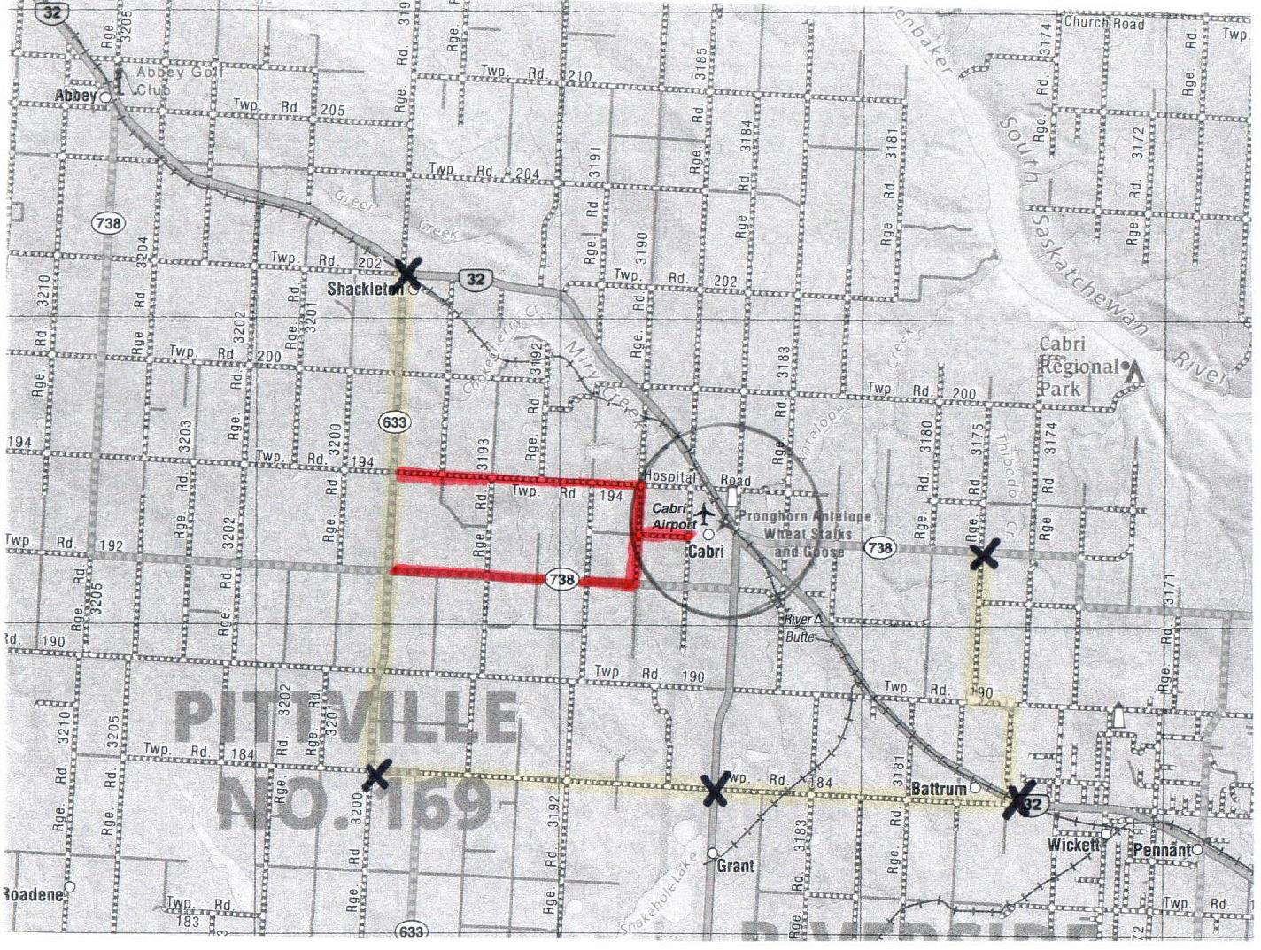

YELLOW= Detour Route RED= Evacuation Route X= Police Officers

SECTION 6 COMMUNICATION PLAN

First choice for communication in the event of an emergency will be cell phones with the use of land lines as required.

The second choice for communication in the event of an emergency will be runners (street captains).

An additional method that may be used is a radio system and social media/town website.

6.1 Priority Contact List

Business Name Contact Name
Cabri Medical Clinic Chelsea Weedon
Prairie Health Care Centre Tracy Stock
Cabri Senior Living Units Cindy Nelson
Evergreen Early Learning Cnt. Rayne Kelsey
Little Learners Childcare Jordan Larochelle
Cabri School Lori Braaten or Deb Thomas
Pioneer Coop Bev Williams
House of Heart Café Paulette Gehl
Lin’s Restaurant Priscilla Lin
Sunrise Inn May Santos
AM Inspection
SWT
Lime Zero Brad Levorson
Innovation CU
Cabri Mall Eddie Gergely
Cabri Agencies
Stark & Marsh
Pic’s Shae Stuart
Post Office Diane Braaten
Limitless Rentals Nikki Wingenbach
Brian’s Autobody Brian Horst
Gehl Automotive Kim Gehl
Grasslands Wellness Jamie Winquist
Judy McGuigan Massage Judy McGuigan

6.2 Communication Fan-Out Chart

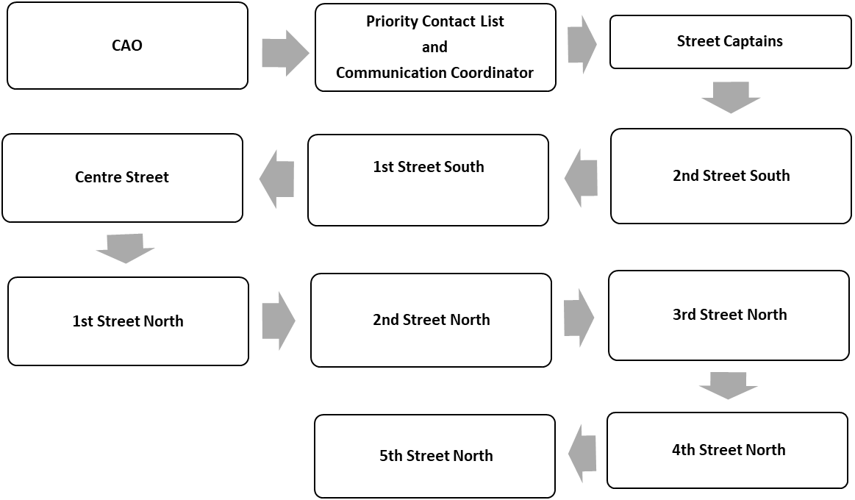
Section 7 Street Captain Information

Street Captain plays an essential role in communicating important information to the public and property owners. This information can vary from an evacuation notice to information that is necessary to communicate to property owners and the public (ie. Boil water advisory etc.).

Street Captains will disseminate information to the individuals within their designated zone. This may be done by a variety of methods including but not limited to: phoning, texting, e-mailing, physical visit to each address to convey the information, or leaving printed material at each address in their zone.

The procedures to be followed will include:

- When it is necessary to communicate information to property owners and the public, the Street Captain will be contacted by the Communication Coordinator. The Communication Coordinator will provide the information that is to be relayed to persons within the Street Captain`s jurisdiction. At this time, the Communication Coordinator will also inform the Street Captains whether it will be necessary to deliver printed material to the properties located within their jurisdiction and how the printed material will be received by the Street Captain.
- The Street Captain will ensure that they have recorded all necessary information accurately. If necessary, the Street Captain will attend at the required location to pick-up the printed material.
- The Street Captain will then relay this information to the persons within their jurisdiction. If it is necessary to deliver printed material to the properties located within their jurisdiction, such information will be delivered in person.
- The Street Captain shall maintain a register of who has been contacted, who they are unable to contact, the method used, as well as the date and time of contact.
- The register listing the persons who they have been unable to contact shall be provided to the Communication Coordinator for further action. The Street Captain shall continue to attempt to contact the persons on this list. If contact is successful, they shall inform the Communication Coordinator of this.

A list of names and contact numbers for the street captains will be provided in a separate, confidential document as required.

Section 8 Emergency Scenarios and Procedures

Identify potential emergency situations/scenarios

Potential  Emergency | Urgency  (1-5) | Severity  (1-5) | Evacuate | Response
Airplane Crash |  |  | Unlikely | Assist  As required
Blizzard/Winter Power Failure |  |  | Potential | EMO Plan
Dangerous Goods – storage |  |  | Potential | EMO Plan
Dangerous Goods – transport |  |  | Potential | EMO Plan
Fire – Major (buildings) |  |  | Potential | EMO Plan
Fire – Forest |  |  | Unlikely | Assist  As required
Fire – Grass |  |  | Potential | EMO Plan
Flood – gradual (run-off) |  |  | Unlikely | Assist  As required
Flood – sudden (flash/dam failure) |  |  | Unlikely | Assist  As required
Health – air quality (smoke) |  |  | Unlikely | Assist  As required
Health – contaminated food |  |  | Unlikely | Assist  As required
Health – contaminated water |  |  | Unlikely | Assist as required/Waterworks  ERP
Health – epidemic/pandemic |  |  | Unlikely | Assist  As required
Pipeline Explosion/Leak |  |  | Potential | EMO Plan
Structural Collapse/Construction Disaster |  |  | Unlikely | Assist as  Required
Tornado, Severe Windstorm |  |  | Potential | EMO Plan
Transportation – Rail Disaster |  |  | Potential | EMO Plan
Transportation – Road/Bus Accident |  |  | Unlikely | Assist as  Required
Transportation – Water |  |  | Unlikely | Assist as  Required
Utility – gas/power failure |  |  | Unlikely | Assist as  Required
Water Shortage |  |  | Unlikely | Assist as  Required
Waste Disposal Contamination |  |  | Unlikely | Assist as  Required

Section 9 EMO Organization Chart

Street Captains

Town Foreman
Sid Sirota
Alternate:
Brenan Thoreson

Supplies & Equpipment Coordinator

Assigned by EMO or CAO
Phoning Coordinator

Assigned by EMO or CAO
Facility Coordinator

Assigned by EMO or CAO
Police
RCMP Detachment
778-5550
Fire

EMO Coordinator

Kim Gehl
Alternate:
Mike Wicks
Communication Coordinator
Brenda Heron

Evacuation Coordinator

Assigned by EMO or CAO

Health
Prairie Health Care Centre
CAO
Janelle Desautels
Alternate: Kristi Jamieson
Mayor and other
Council Members
David Gossard
Jim Wallis
Kim Lacelle
Norma Pederson
Wendy Johnson
Dani Sorenson

Site Commander
As Assigned by EMO
EMS
Provincial Emergency Services Officer
Sterling Switzer
306-930-8726
Sterling.switzer@gov.sk.ca

Transportation Coordinator
Assigned by EMO or CAO

SCHEDULE 1 DEPUTY MAYOR ROTATION

DEPUTY MAYOR ROTATION FOR THE YEARS 2020 THROUGH 2024

- November 2020 to June 2021- Kim Gehl

- July 2021 to February 2022 – Norma Pederson

- March 2022 to October 2022 – Wendy Johnson

- November 2022 to June 2023 – Kim Lacelle

- July 2023 to February 2024 – Jim Wallis

- March 2024 to October 2024 – Dani Sorenson

*These appointments shall take effect on the first day of each month respectively.

